## **Writing the code**

How do we implement this in Python

1. Here is the Python code for Gradient descent 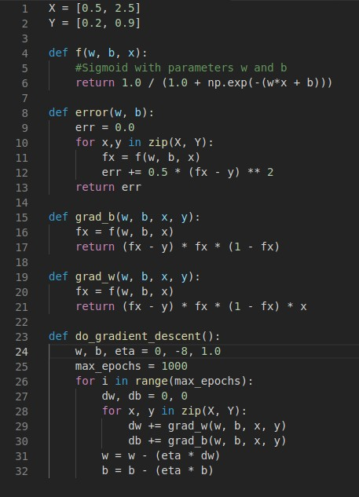
2. This is how the algorithm works 